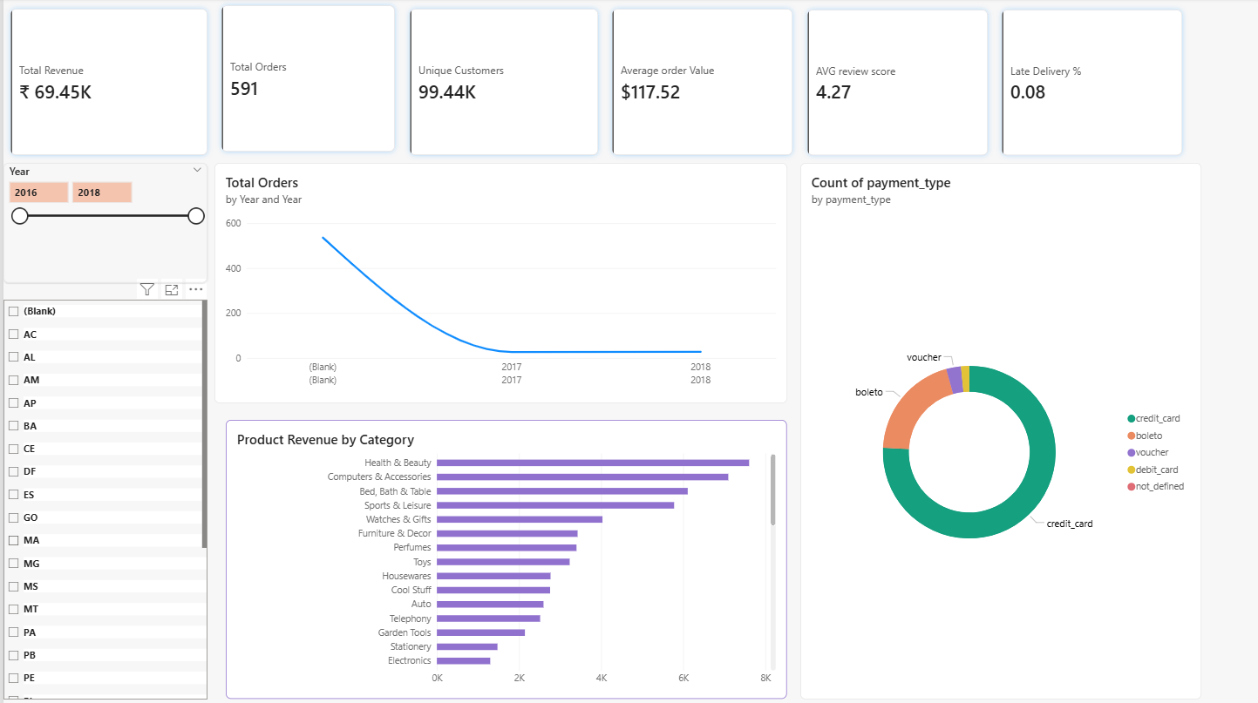
Executive Overview
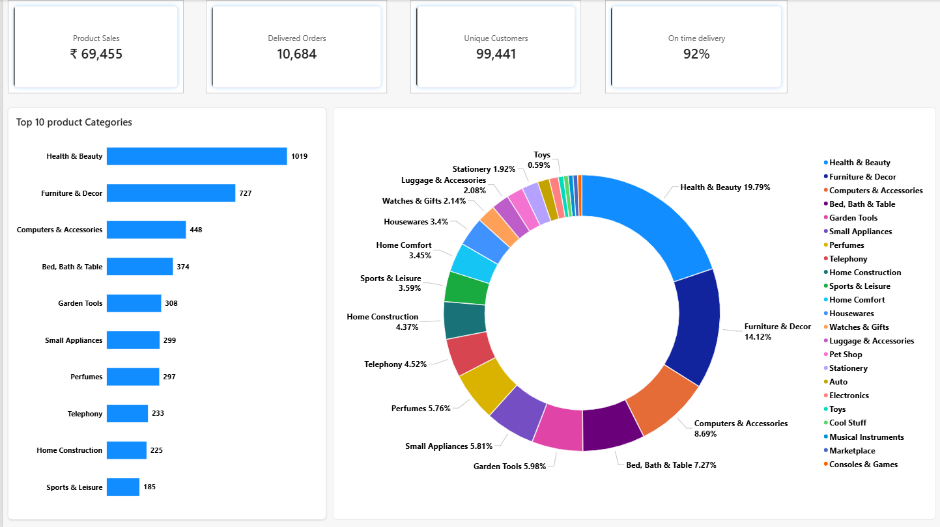
Sales and Revenue Analytics

Commerce 360 — E-commerce Analytics
1. Project Overview
Commerce 360 is an end-to-end e-commerce analytics project designed to analyse revenue trends, product category performance, customer purchasing behaviour, and delivery performance.
Objective:
The objective is to transform raw e-commerce data into reliable business insights and interactive Power BI dashboards that support data-driven decisions.
2. Business Problem
The business needs to understand which product categories drive sales, whether customers make repeat purchases, how revenue changes over time, and where delivery performance may require improvement.
3. Project Objectives
- Analyse monthly sales trends and growth.
- Identify top-performing product categories.
- Measure unique customers and repeat purchasing.
- Evaluate on-time delivery performance.
- Examine the relationship between delivery delays and customer reviews.
- Build an interactive Power BI dashboard.
4. Dataset
Source: Brazilian E-Commerce Public Dataset by Olist
Dataset link: https://www.kaggle.com/olistbr/brazilian-ecommerce
The dataset contains related tables covering orders, order items, customers, products, sellers, payments, reviews, and product category translations.
The analysis uses historical data. The exact date range, row counts, and exclusions will be documented after inspecting the downloaded files.
5. Tools and Technologies
- Excel: Initial inspection and data review
- Python: Data cleaning and exploratory data analysis using pandas
- MySQL: Data querying and business analysis
- Power BI: Data modelling, DAX measures, and interactive dashboards
- GitHub: Version control and project documentation
6. Methodology
- Understand the business problem and define analytical questions.
- Inspect the source tables and document the data dictionary.
- Clean and validate the data using Python and Power Query.
- Load the required tables into MySQL.
- Perform SQL analysis and validate the results.
- Build the Power BI data model and KPI measures.
- Create dashboards and test filters and calculations.
- Summarize evidence-based findings and business recommendations.
7. Dashboard Pages
- Executive Overview
- Sales and Revenue Analysis
- Customer Analytics
- Delivery and Customer Experience

8. Key Findings
Add your actual findings after completing the analysis. Include the relevant metric, time period, comparison, and evidence.
9. Business Recommendations
Describe practical actions supported by your findings and specify the metrics that should be monitored to evaluate their effectiveness.
10. Data Validation
Document duplicate checks, null-value analysis, join validation, metric definitions, and reconciliation between SQL results and Power BI visuals.
11. Limitations
Document historical data coverage, missing values, metric assumptions, and any factors that prevent a result from being interpreted as causal.
12. How to Reproduce the Analysis
Provide the dataset download instructions, required software, SQL execution order, Python environment requirements, and steps to open or refresh the Power BI report.
13. Project Deliverables
- Python analysis notebook
- SQL scripts
- Power BI report
- Data dictionary and KPI definitions
- Dashboard screenshots
- Business findings and recommendations

